Ex. No. : 06 Date :
Register No. : 221701007 Name : AMRITHA A

SD Card
Aim
Implement an application to write the Register Number, Name and CGPA to the SD card in text file format.
Procedure:
Step 1 : File → New Project
Provide the application name (e.g.,"SD Card") and click “Next”.
Step 2 : Select the target Android devices
Select the minimum SDK to run the application. Click “Next”.
Step 3 : Choose the activity for the application
By default, choose “Blank Activity”. Click “Next”.
Step 4 : Enter activity name and click “Finish”.
Step 5 : Edit the program
Request storage permissions in the manifest file.
Use file input/output streams in MainActivity.kt to read from and write to
SD card or internal storage.
Step 6 : Run the application
Two ways to run the application:
1. Running through emulator (with SD card configured)
2. Running through mobile device
AndroidManifest.xml

<?xml version="1.0" encoding="utf-8"?>
<manifest xmlns:android="http://schemas.android.com/apk/res/android"
xmlns:tools="http://schemas.android.com/tools">

<application
android:allowBackup="true"
android:dataExtractionRules="@xml/data_extraction_rules"
android:fullBackupContent="@xml/backup_rules"
android:icon="@mipmap/ic_launcher"
android:label="@string/app_name"
android:roundIcon="@mipmap/ic_launcher_round"
android:supportsRtl="true"
android:theme="@style/Theme.SdCard"
tools:targetApi="31">
<activity
android:name=".MainActivity"
android:exported="true">
<intent-filter>
<action android:name="android.intent.action.MAIN" />

<category android:name="android.intent.category.LAUNCHER" />
</intent-filter>
</activity>
</application>

</manifest>

Activity_main.xml

<?xml version="1.0" encoding="utf-8"?>
<LinearLayout xmlns:android="http://schemas.android.com/apk/res/android"
xmlns:app="http://schemas.android.com/apk/res-auto"
xmlns:tools="http://schemas.android.com/tools"
android:layout_width="match_parent"
android:layout_height="match_parent"
android:orientation="vertical"
android:padding="16dp"
tools:context=".MainActivity">

<TextView
android:layout_width="match_parent"
android:layout_height="wrap_content"
android:text="SD Card"
android:textSize="24sp"
android:textStyle="bold"
android:textColor="@android:color/white"
android:background="#6200EE"
android:padding="12dp"/>

<LinearLayout
android:layout_width="match_parent"
android:layout_height="wrap_content"
android:orientation="vertical"
android:layout_marginTop="16dp">

<EditText
android:id="@+id/editTextRegisterNumber"
android:layout_width="match_parent"
android:layout_height="wrap_content"
android:hint="Enter the register number..."
android:inputType="text"
android:padding="12dp"
android:background="@drawable/edit_text_background"
android:layout_marginBottom="8dp"/>

<EditText
android:id="@+id/editTextName"
android:layout_width="match_parent"
android:layout_height="wrap_content"
android:hint="Enter the name..."
android:inputType="textPersonName"
android:padding="12dp"
android:background="@drawable/edit_text_background"
android:layout_marginBottom="8dp"/>

<EditText
android:id="@+id/editTextCGPA"
android:layout_width="match_parent"
android:layout_height="wrap_content"
android:hint="Enter the CGPA..."
android:inputType="numberDecimal"
android:padding="12dp"
android:background="@drawable/edit_text_background"
android:layout_marginBottom="16dp"/>

<Button
android:id="@+id/buttonSave"
android:layout_width="match_parent"
android:layout_height="wrap_content"
android:text="Save"
android:textColor="@android:color/white"
android:backgroundTint="#6200EE"
android:padding="12dp"
android:layout_marginBottom="8dp"/>

<Button
android:id="@+id/buttonLoad"
android:layout_width="match_parent"
android:layout_height="wrap_content"
android:text="Load"
android:textColor="@android:color/white"
android:backgroundTint="#6200EE"
android:padding="12dp"/>
</LinearLayout>

</LinearLayout>

MainActivity.kt

package com.example.sdcard

import android.Manifest
import android.content.pm.PackageManager
import android.os.Bundle
import android.os.Environment
import android.widget.Button
import android.widget.EditText
import android.widget.Toast
import androidx.appcompat.app.AppCompatActivity
import androidx.core.app.ActivityCompat
import androidx.core.content.ContextCompat
import java.io.File
import java.io.FileOutputStream
import java.io.IOException

class MainActivity : AppCompatActivity() {
private lateinit var registerNumberEditText: EditText
private lateinit var nameEditText: EditText
private lateinit var cgpaEditText: EditText
private lateinit var saveButton: Button
private lateinit var loadButton: Button

private val STORAGE_PERMISSION_CODE = 100

override fun onCreate(savedInstanceState: Bundle?) {
super.onCreate(savedInstanceState)
setContentView(R.layout.activity_main)

// Initialize UI components
registerNumberEditText = findViewById(R.id.editTextRegisterNumber)
nameEditText = findViewById(R.id.editTextName)
cgpaEditText = findViewById(R.id.editTextCGPA)
saveButton = findViewById(R.id.buttonSave)
loadButton = findViewById(R.id.buttonLoad)

// Request storage permissions
requestStoragePermission()

// Set click listeners
saveButton.setOnClickListener {
saveDataToSD()
}

loadButton.setOnClickListener {
loadDataFromSD()
}
}

private fun requestStoragePermission() {
if (ContextCompat.checkSelfPermission(
this,
Manifest.permission.WRITE_EXTERNAL_STORAGE
) != PackageManager.PERMISSION_GRANTED
) {
ActivityCompat.requestPermissions(
this,
arrayOf(
Manifest.permission.WRITE_EXTERNAL_STORAGE,
Manifest.permission.READ_EXTERNAL_STORAGE
),
STORAGE_PERMISSION_CODE
)
}
}

private fun saveDataToSD() {
// Validate inputs
val registerNumber = registerNumberEditText.text.toString().trim()
val name = nameEditText.text.toString().trim()
val cgpa = cgpaEditText.text.toString().trim()

if (registerNumber.isEmpty() || name.isEmpty() || cgpa.isEmpty()) {
Toast.makeText(this, "Please fill all fields", Toast.LENGTH_SHORT).show()
return
}

try {
// Try multiple storage options for emulator compatibility
val file = try {
// Option 1: Using app-specific external storage (works on most emulators)
val appDir = getExternalFilesDir(null)
val dir = File(appDir, "SDCardApp")
if (!dir.exists()) {
dir.mkdirs()
}
File(dir, "$registerNumber.txt")
} catch (e: Exception) {
// Option 2: Using legacy external storage as fallback
val dir = File(Environment.getExternalStorageDirectory(), "SDCardApp")
if (!dir.exists()) {
dir.mkdirs()
}
File(dir, "$registerNumber.txt")
}

// Create file
val fileOutputStream = FileOutputStream(file)
val data = "Register Number: $registerNumber\nName: $name\nCGPA: $cgpa"

fileOutputStream.write(data.toByteArray())
fileOutputStream.close()

Toast.makeText(this, "Data saved successfully to ${file.absolutePath}", Toast.LENGTH_LONG).show()

// Clear fields after saving
registerNumberEditText.text.clear()
nameEditText.text.clear()
cgpaEditText.text.clear()

} catch (e: IOException) {
e.printStackTrace()
Toast.makeText(this, "Error saving data: ${e.message}", Toast.LENGTH_SHORT).show()
}
}

private fun loadDataFromSD() {
val registerNumber = registerNumberEditText.text.toString().trim()

if (registerNumber.isEmpty()) {
Toast.makeText(this, "Please enter a register number", Toast.LENGTH_SHORT).show()
return
}

try {
// Try to find the file in multiple storage locations
val file = findDataFile(registerNumber)

if (file == null || !file.exists()) {
Toast.makeText(this, "No data found for this register number", Toast.LENGTH_SHORT).show()
return
}

val fileContent = file.readText()
val lines = fileContent.split("\n")

// Parse the data
for (line in lines) {
when {
line.startsWith("Name:") -> {
val name = line.substring(line.indexOf(":") + 1).trim()
nameEditText.setText(name)
}
line.startsWith("CGPA:") -> {
val cgpa = line.substring(line.indexOf(":") + 1).trim()
cgpaEditText.setText(cgpa)
}
}
}

Toast.makeText(this, "Data loaded successfully from ${file.absolutePath}", Toast.LENGTH_SHORT).show()

} catch (e: IOException) {
e.printStackTrace()
Toast.makeText(this, "Error loading data: ${e.message}", Toast.LENGTH_SHORT).show()
}
}

private fun findDataFile(registerNumber: String): File? {
// Try app-specific external storage first
val appDir = getExternalFilesDir(null)
val appSpecificDir = File(appDir, "SDCardApp")
var file = File(appSpecificDir, "$registerNumber.txt")

if (file.exists()) {
return file
}

// Try legacy external storage
try {
val externalDir = File(Environment.getExternalStorageDirectory(), "SDCardApp")
file = File(externalDir, "$registerNumber.txt")
if (file.exists()) {
return file
}
} catch (e: Exception) {
// Ignore and continue to other options
}

// Try cache directory as last resort
val cacheDir = File(cacheDir, "SDCardApp")
if (!cacheDir.exists()) {
cacheDir.mkdirs()
}
file = File(cacheDir, "$registerNumber.txt")
if (file.exists()) {
return file
}

return null
}

// Checks if external storage is available for read and write
private fun isExternalStorageWritable(): Boolean {
return Environment.getExternalStorageState() == Environment.MEDIA_MOUNTED
}

// Checks if external storage is available to at least read
private fun isExternalStorageReadable(): Boolean {
return Environment.getExternalStorageState() in
setOf(Environment.MEDIA_MOUNTED, Environment.MEDIA_MOUNTED_READ_ONLY)
}

override fun onRequestPermissionsResult(
requestCode: Int,
permissions: Array<String>,
grantResults: IntArray
) {
super.onRequestPermissionsResult(requestCode, permissions, grantResults)
if (requestCode == STORAGE_PERMISSION_CODE) {
if (grantResults.isNotEmpty() && grantResults[0] == PackageManager.PERMISSION_GRANTED) {
Toast.makeText(this, "Storage permission granted", Toast.LENGTH_SHORT).show()
} else {
Toast.makeText(this, "Storage permission denied", Toast.LENGTH_SHORT).show()
}
}
}
}

Output

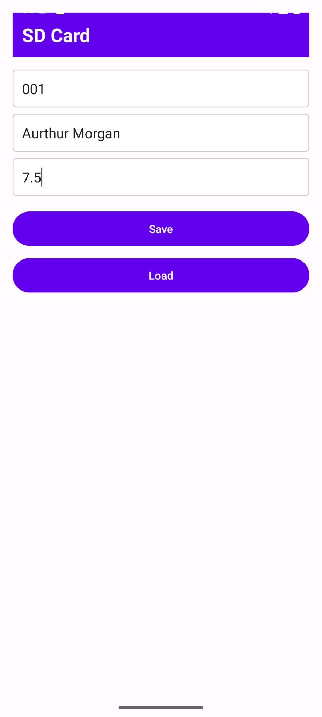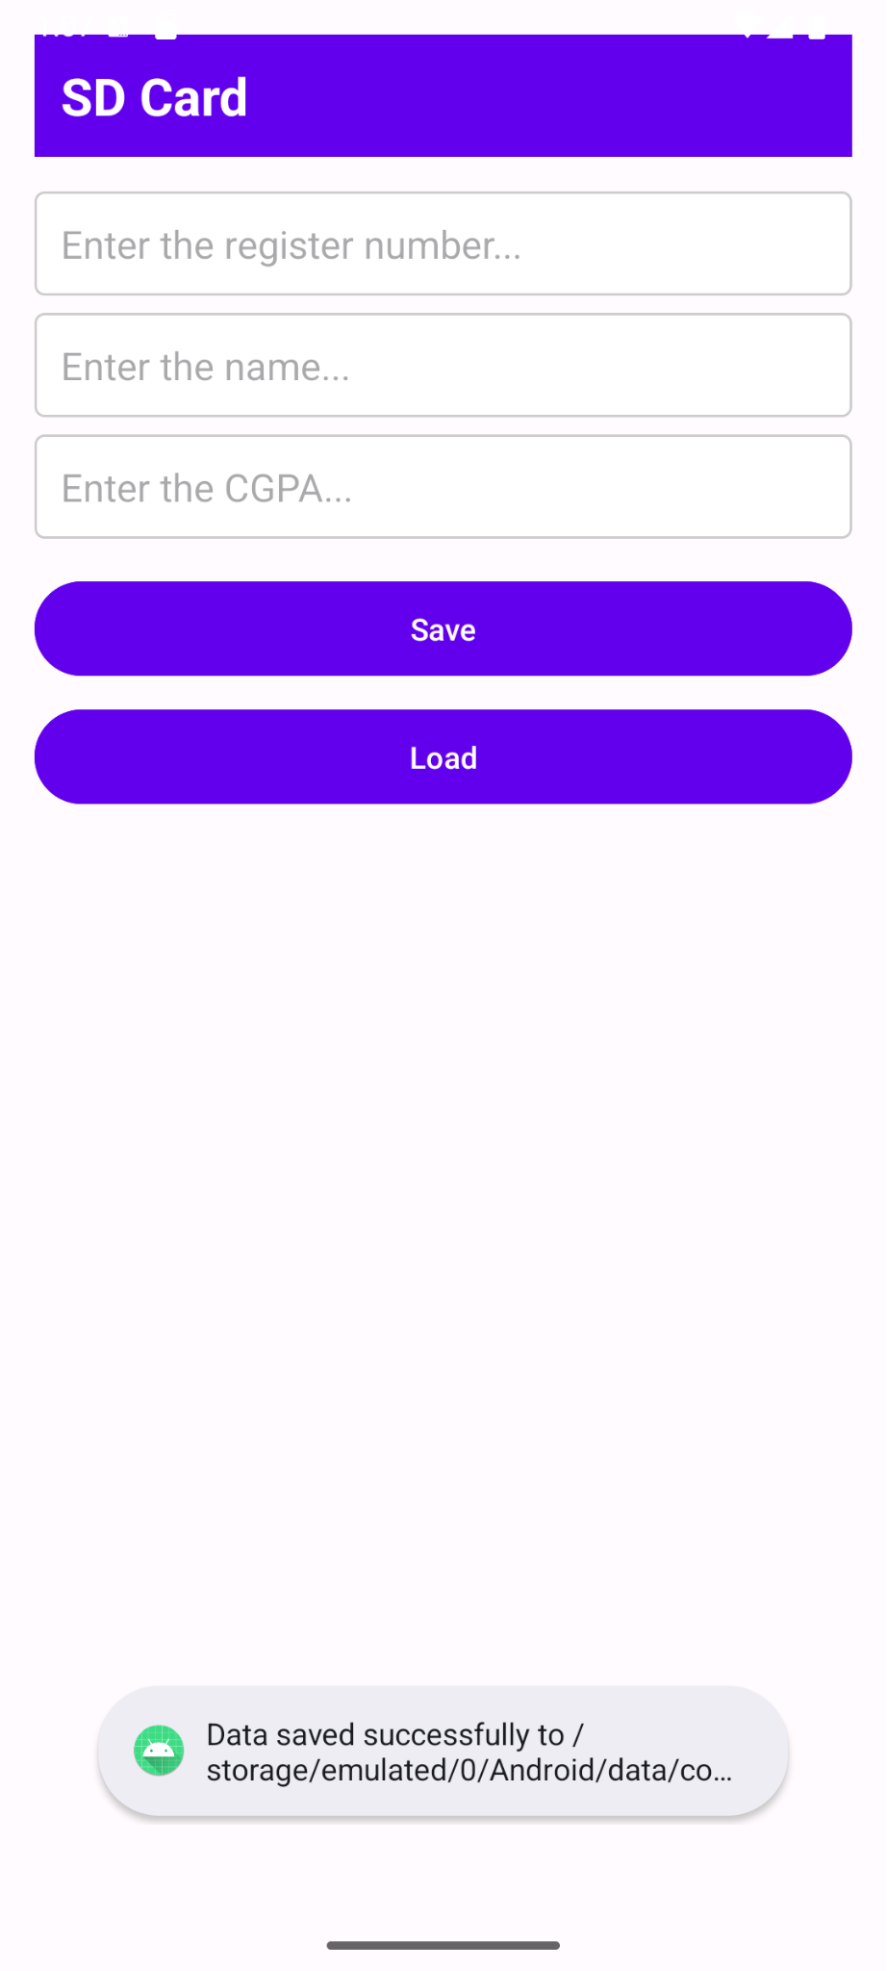

Result:
The SD Card Access application successfully reads and writes data to the SD card or internal storage when tested on a mobile device with appropriate permissions.

